DIANA NDINDA NYAMAI

1033977

SKINCARE MANAGEMENT SYSTEM PROJECT

# Declaration

I have submitted this project on my own behalf. I declare that the project submitted is original except for the source material acknowledged. The piece of work has not been submitted for more than one purpose without declaration.

This project work is submitted in the partial fulfilment of the requirements for the award of the degree of Bachelor of Science in Computer Science. The results embodied in this report have not been submitted to any other University or Institute for the award of any degree or diploma.

# Acknowledgement

I acknowledge that I am aware of the University policy and regulations on the honesty in academic work and the disciplinary guidelines and procedure that come with breach of these policies and regulations as contained in the universities student’s handbook.

# Dedication

I dedicate this project to my dear parents, relatives, supervisor and friends who have been a source of encouragement and insight throughout its development and who have in different ways supported and inspired me from the start of the project to its completion.

# Abstract

Project development is a crucial and fundamental unit in Computer Science. This is because the project is what is used to gauge the practical understanding of the student in most of the units taught during the curriculum. It tests the student’s skills in system analysis and design during the project development, Entrepreneurship in terms of what solution is the student trying to provide in the current market and system skills development in the language of the student’s choice together with tools used. The proposed system targets management of the skin by educating the users though a web application and recommending the best products for their skin The system is client-based for the users and dermatologist and expected time to completion is six months.

Table of Contents

Declaration i

Acknowledgement ii

Dedication iii

Abstract iv

CHAPTER 1: INTRODUCTION 1

1.1. Motivation and background 1

1.2. Background of research 3

1.3. Problem Statement 4

1.4. Aim of research 5

1.5 Objectives of research 6

1.6. Justification of research 6

1.7. Scope of research 7

1.7. Research organisation 7

CHAPTER 2: RESEARCH METHODOLOGY 8

2.3. Methodology for requirement specification, data collection and analysis techniques 13

2.4. Methodology for system analysis 13

2.5. methodology for system design 13

2.6. Methodology for system implementation 13

2.7. Methodology for system testing 13

2.8. Methodology for system deployment 13

2.9. Chapter summary 13

CHAPTER 3: REVIEW OF RELATED WORK 13

3.1. Chapter introduction 13

3.2. History of research topic 13

3.3. Review of related prototypes, systems 13

3.4. Emerging trends and patterns in the research area 13

3.5. Research gap 13

3.6. chapter summary 13

CHAPTER 4: SYSTEM ANALYSIS 14

4.1. Chapter introduction 14

4.2. description of the current system 14

4.3. Feasibility study and its conclusion 14

4.4. data input and output analysis 14

4.5. process logic design of the current system 14

4.6. Chapter summary 14

CHAPTER 5: SYSTEM DESIGN OF THE PROPOSED SYSTEM 14

5.1 Introduction 14

5.2. description of the proposed systems 14

5.3. Requirement analysis 14

5.4. Conceptual architecture of the proposed system 14

5.5. process logic design of the proposes 14

5.6. database design 14

5.7. input and output of the proposed system 14

5.8. chapter summary 14

Data analysis of system 14

Process Logic Design 17

Database design 19

CHAPTER 6: IMPLEMENTATION SYSTEM AND TESTING 23

6.1. Chapter Introduction 23

6.2. System screenshots 23

6.3. Testing plan 23

6.4. Evaluation plan 23

6.5. Chapter summary 23

CHAPTER 7: CONCLUSIONS, FINDINGS & RECOMMENDATIONS 26

7.1. Introduction 26

7.2. Conclusion 26

7.3. Challenges Encounter 26

7.4. Future recommendations 26

7.5. Conclusion 26

REFERENCES/BIBLIOGRAPHY 27

APPENDIX 28

# CHAPTER 1: INTRODUCTION

## 1.1. Motivation and background

In the past years, people have developed interest (both women and men) in skincare and have depended on the best seller for products or recommendations from the stores over the counter. However, each person has a different skin type and skin conditions, thus the old methods are not effective to judge compatibility of a product and a user.

Skincare is the range of practices that care for the skin, enhance its appearance and relieve skin conditions. They can include nutrition, avoidance of excessive sun exposure and appropriate use of emollients. Practices that enhance appearance include the use of cosmetics, exfoliation and ultrasonic skin treatment.

Taking care of your face and skin is a lot like taking care of your teeth. It takes a routine of proper cleansing(flossing) and moisturizing (brushing) every day, with the right tools and products to keep your pores clean and face glowing

The art of skincare goes way back to the 1500 BC when sandpaper was used to exfoliate the skin and smoothen the scars. From then the art of skincare continued to evolve and continue to evolve till now. Some of the first humans used paint to draw images onto cave walls and used the same paint on their facial features sometimes to make them look better and other times to make them look more threatening.

The first recorded case was from the Ancient Egypt who took skincare seriously then the Greek and the romans borrowed from the Egyptians who also took the skincare and makeup seriously from using Honey as a moisturizer, while oils and sand were used as a natural sunscreen.

The next recorded skincare was in China around 1760 BC during the Shang dynasty who valued the natural pale look and used face powders from lead and skin lighteners made from songyi mushrooms to get the desired look which later spread and became popular across Europe.

The modern skincare started with formation of FDA in 1906 to regulate the industry. This time companies like Maybelline, Max Factor launched all range of skin care products and the world of cosmetics began. Today skincare has advanced and companies work towards developing new products whose objective is to improve the look and the feel of the skin.

The customer visits a store to purchase products that can work with their skin. The skin specialists give advice on which products to purchase whether its dealing with acne or enhancing the skin depending on the skin type (normal, oily, dry, combination or sensitive) and the number of times the consumer should use the products in a week or day. For example, the max number of times you can use a facemask is 3days in a week while serum you can use it daily.

In case the customer who visits the cosmetic store cannot be attended to a store the skin specialist will recommend to go to a hospital or dermatologist.

The customers can also visit dermatologist to get their skin tested and get professional help to treat their skin. The hospital will then keep records of the customers condition so that when the customer gets to come back, they can be able to trace the documents without having to repeat the process of testing the skin type.

## 1.2. Background of research

**Types of skin**

We all have different skin types. There are five different types of skin which include:

* Normal skin – its neither too dry nor too oily. Has no or few imperfections. Has no severe sensitivity. Barely visible pores
* Dry skin – have almost invisible pores. Dull, rough complexion. Skin is less elastic
* Oily skin – have enlarged pores. Dull or shiny, thick complexion. Prone to pimples or acne. Have blemishes
* Combination skin – the skin can be dry or normal and in some areas oily such as the T-zone (forehead, nose and chin). Pores look larger than the normal skin. Have blackheads and a shiny skin
* Sensitive skin – the skin is prone to inflammation and it has burning feeling

**How does one care for the skin?**

The process of caring for the skin is an important task which ensures the skin is in a good condition. For one to care for his/her skin one needs to understand and know their skin type which includes: normal, dry, oily, sensitive skin, acne prone, mature, dull skin and rough skin.

There are also concerns in which one may one to treat the skin which includes: acne or breakouts, blackhead, dark spots, large pores, skin firming, sunburn, uneven skin tone, wrinkles etc.

The various ways in which one can care for the skin includes:

* **use of sunscreen –** protection from the sun is an important aspect because it presents the skin from skin cancer and faster aging and the appearances of sunburns
* **cleansing –** this involves cleaning of the face using a cleanser to remove all the dirt from your skin that you had gotten during the day
* **use of serums –** a serum is skincare product that mostly contains vitamin C and it aids in clearing wrinkles, blackspots, enlarged pores, and uneven skin tone
* **use of moisturizer –** moisturizing your skins aids in fighting wrinkles, reduces the appearance of blemishes, reduces the chance of having skin problems, helps in your skin staying young

**Ways of treating the skin include:**

**Acne:** acne treatment depends on how serious your acne is but the following are some the treatments for a mild acne include:

* adapalene
* tee tree oil
* salicylic acid
* benzoyl peroxide
* alpha hydroxy acids

**Sebaceous filaments:** these are tiny cylinder-like tubes in your pores that are whitish yellow.

The treatment include: seeing a dermatologist to have them removed or applying benzol peroxide after washing before extraction

**Blemishes, scars and hyperpigmentation:** treatment for this include use of sunscreen, use of honey, vitamin C, niacinamide retinoic acid. etc.

## 1.3. Problem Statement

From the research carried out, various problems were identified. These problems were seen when the system was manual.

* The records of the data of the customer are manual and incase the documents are lost there’s a risk that the management will not be able to trace the data.
* Although there are all sorts of products of skincare the challenge comes when the products don’t work on your skin and ends up making it worse or causing skin problems that were initially not there. Statistics shows that only 37% of consumers claim they will only purchase products from brands they can trust and this shows that not all products offered by different companies are safe for your skin and the question arises, how do you know which product to purchase? And how will your skin react to it? Is it safe for your skin?
* The customers need to visit the store or a dermatologist directly and the appointments or reservations have to be carried out physically leading t.
* The customers don’t understand or know their skin types hence ends up using products that are not friendly to their skin. Or not knowing which products to get
* There is no progress of the customer skin improvements being recorded.
* The store a customer visits may overprice them on the product
* The store that the customer visits may have products that aren’t authentic and end up using products that can affect them.

## 1.4. Aim of research

The aim of this project is to:

* ensure the customers/users get the best organic products that are safe and friendly to their skin and provide a skincare routine to follow daily or weekly at the comfort of their home
* enable the customers to get a professional advice from a dermatologist if the condition doesn’t improve or id the user has a skin condition.
* allow the customers to book an appointment with a dermatologist without having to be there physically and get professional advice and treatment.
* educate the user about their skin type through getting their information like age, gender.
* keep track of the customers’ progress on the skin’s improvement
* enable the customer to get to use products that are authentic and are recommended by dermatologist.
* record the number of new customers to visit the system and generate user visits reports.
* record the number of appointments made daily, weekly and monthly and generate reports on the availability of the dermatologist.
* record the products that are mostly being purchased and generate reports on the products preferred according to the trends.

## 1.5 Objectives of research

At the end of this project, I will be able to come up with a system that will:

* ensure the customers/users get the best organic products that are safe and friendly to their skin and provide a skincare routine to follow daily or weekly at the comfort of their home
* enable the customers to get a professional advice from a dermatologist if the condition doesn’t improve or id the user has a skin condition.
* allow the customers to book an appointment with a dermatologist without having to be there physically and get professional advice and treatment.
* educate the user about their skin type through getting their information like age, gender.
* keep track of the customers’ progress on the skin’s improvement
* enable the customer to get to use products that are authentic and are recommended by dermatologist.
* record the number of new customers to visit the system and generate user visits reports.
* record the number of appointments made daily, weekly and monthly and generate reports on the availability of the dermatologist.
* record the products that are mostly being purchased and generate reports on the products preferred according to the trends.

## 1.6. Justification of research

Users need a transparent way of knowing about their skin types and getting products suitable for their skin types. The proposed system delivers exactly this plus allows users to book appointment with a doctor remotely. The proposed system also negates any previous inconveniences to the user such as having to visit the cosmetic stores or having to visit the dermatologist physically to book an appointment. Finally, the system has functionality of being able to generate reports in order to help in improving the system.

## 1.7. Scope of research

From the previous problems that were identified in the previous manual system, my proposed system will be able:

* To ensure the customers/users get the best organic products that are safe and friendly to their skin and provide a skincare routine to follow daily or weekly at the comfort of their home
* To enable the customers to get a professional advice from a dermatologist if the condition doesn’t improve.
* To allow the customers to book an appointment with a dermatologist without having to be there physically and get professional advice and treatment.
* To educate the user about their skin type through getting their information like age, gender and few home tests to determine skin type.
* To keep track of the customers’ progress on the skin’s improvement
* To enable the customer to get to use products that are authentic.
* To record the number of new customers to visit the system and generate user visits reports.
* To record the number of appointments made daily, weekly and monthly and generate reports on the availability of the dermatologist.
* To record the products that are mostly being purchased and generate reports on the products preferred according to the trends.
* To record the user’s feedback used to generate reports to improve the system.
* To record the user’s previous diagnosis and generate reports to refer to on the next visit.

## 1.7. Research organisation

# CHAPTER 2: RESEARCH METHODOLOGY

**2.1. Introduction**

This chapter focuses on the methods that have been used in the collection and analysis of data for the project. It explains the research design and data collection methods used and describes how data collected from the research has been analyzed.

The research method to be used is qualitative research which is usually associated with getting people's views and thoughts. This involves collecting data, data analysis and attempting to uncover the deeper meaning to the collective data. Collection of data will be done through observation and interviews and both descriptive data analysis and inferential data analysis will be used to analyze the data.

**2.2. Methodology for Literature Review**

When it comes to skin care, peoples first thought is about their faces. The skin is the largest part of our body hence it is important to keep it properly nourished. In 1967, a zoologist Desmond Morris stated that “flawless skin is the most universally desired human feature” explaining the ancient human need to advertise health, wellbeing and fertility with an even-toned complexion. In the pursuit to achieve a perfect skin, consumers are willing to search the best skincare products. May it be in department stores or online, the consumers are faced with dilemma on the product to choose. They look to their friends, physicians, favorite influencer or blogger for recommendations, often purchasing expensive products that fail to live up to their supposed benefits.

A market survey was conducted in October 2015 and it showed that most consumers perceived factors like regular facial cleaning, lifestyle and sun exposure was ranked higher and it impacted the skin’s appearance compared to visiting a dermatologist or getting professional skincare treatment.

A stable growth of the cosmetic industry (skin care products) and progressive technology has caused an intense competition in the cosmetics companies. The cosmetic firms are forced to create, innovate and to upgrade their products. There is a need for developing revolutionary technologies and shifting customers’ demands and needs, contribute towards increasing cosmetic companies’ abilities to produce various kinds of cosmetic merchandises (Kumar, Massie, & Dumonceaux, 2006).

**Case study of soko glam**

Soko Glam is an online marketplace that specializes in Korean beauty products. Soko Glam was founded on 1st December 2012 by an esthetician and author Charlotte Cho and David K. Cho. The headquarters are in New York City. Soko Glam operates as an online retailer of Korean beauty products and treatments, specializing in Skin care, hair and makeup. The user can either go ahead to make the purchases of products or get to know of his/her skin by taking a test which is available in the system. The test involves answering nineteen questions about your skin, for example the age, whether you work out, time you spend on the sun etc. and the system lets you know of your skin type and products that you may use to improve on the are of concern on your skin.

The features on Soko Glam include:

* An online method of consultation with an esthetician in the system and book an appointment
* It notifies the user about trending products on the market through email
* A ready online market where the user can shop the product from
* An online consultation method with an esthetician
* Allows user to make reviews on the system on the products they purchased
* Availability of blogs in the system to educate the users more on taking care of skin and understanding their skin better
* Has user friendly navigation where the user can easily navigate through the system with much guidance

**Case study of skin care by alana**

Skin care by Alana is an android and IOS application than you can freely download, which serves as a skincare management system. The application was founded by Alana family. Notable strongholds offered .by Skin care by Alana include:

* Online method of enquiring about the skin type and recommending the products to use and to purchase from their application.
* The availability of a licensed esthetician who can review your information and respond to you with analysis and recommendations for the products that will get on your way to a good skin.
* Availability of communication through email where the user can email the company in case of any inquiries.
* An online store where you can order the products from the application and have them delivered to your doorstep.
* Blog section where the user can get educated more about skin care.

**Case study of rynkl**

RYNKL is a wrinkle analysis application free to download that helps the users to track signs of aging on the skin using artificial intelligence to make the skin look younger. The application is free to download and doesn’t contain in-app purchases. The application was developed by youth laboratories located in Hong Kong, Hong Kong Island and that was founded on August 15, 2015.The founder is Alex Zhavoronkov.

Youth Laboratories develops algorithms for images analysis and implement them into mobile applications. The algorithm utilizes machine learning and Deep-learning methods, big data analytics, and the latest research in biology to extract facial traits from selfies.

Their first product was RYNKL which allows one to track facial wrinkles and evaluates the effect of anti-aging treatments through making selfies.

**Case study of TD**

TD is a skincare recommendation system available on IOS and Android. The application that can be downloaded from google play store and apple store. The application identifies and assesses any potentially risky or toxic ingredients in beauty and skincare products. The application was started by founder Lily Tse who wanted to avoid toxic ingredients and find safer alternatives due to a family history of cancer.

The main aim of the company is to educate the users of the industry by allowing them to make an informed decision on what products to purchase.

What the application basically does is scan the users item (product) barcode and the application will give you an easy-to-follow breakdown of the product’s ingredients and where they fall on a potential health hazard scale.

It also gives suggestions for a safer product as an alternative of the product you had chosen to purchase.

The application is free to download but offers a subscription if you need to get unlimited suggestions on the products you purchase in their application.

The weakness in this system is that it doesn’t have a specialist who can confirm whether the products they recommend or suggest to the users are actually safe for them to use. It also doesn’t have a way for them to get educate the users on their skin types and whether the products they are purchasing could be compatible with their skin.

There’s is also no way for the system to be able to recommend the user to visit a specialist if the skin condition requires a specialist(dermatologist) to handle.

**Case study of sunzapp**

Sunzapp is android application that makes it easier for the users to have fun in the sun without getting burned. The application was developed by Klein Buendel in (2014). It reminds the user to apply sunscreen incase one had forgotten to protect your skin against the sun. The application’s advice is based on the location of the user, environmental conditions, sunscreen SPF(sun protection factor) and UV (ultraviolet radiation) index forecast.

The application also enables each user to add up to 5 profiles which can be customized for your favorite outdoor activities.

Sunzapp features include:

* A personalized real-time data – Sunzapp uses NOAA’s (National Oceanic and Atmospheric Administration) hour-by-hour forecast to provide real-time sun protection advice for your profile.
* Timer and alerts – Sunzapp times your UV exposure and sends alerts about when you should sunscreen or when to get out of sun to avoid painful sunburn
* Sun protection tips – Sunzapp gives advice about when to cover-up clothing, sunglasses, hats and shade
* Multiple profiles – Sunzapp lets you add multiple profiles for yourself and family
* Planning function – Sunzapp helps you to plan for an event up to five days in the future.

**Literature review summary**

Having a done a review on the above systems and considered all their features. I have sorted the systems from the ones with most features to the least.

* Soko glam which is an online market place that allows its users to shop and also get to learn about their skin through the systems blog and also consult with the system’s esthetician.
* Skincare by alana is system that enables its users to get to know about their skin through their blogs and also allow the user o make purchases within the system
* TD is a system that allows user to be aware of the products they are using. That is if the product contains toxins that can harm the skin and get to recommend a better product to the user
* Sunzapp is a system that alerts the user when to be out of the sun and reminds the user to apply sunscreen to protect the user against the harmful sun rays
* Rynkl is an wrinkle detection application/system that uses artificial intelligence to scan the user’s skin to detect any signs of aging to the user .

In the view of the above I would recommend on the use of soko glam. The reason behind that being the system can let you know of your skin type and advice you on the products to use and the skin care routine to follow.

## 2.3. Methodology for requirement specification, data collection and analysis techniques

## 2.4. Methodology for system analysis

## 2.5. methodology for system design

## 2.6. Methodology for system implementation

## 2.7. Methodology for system testing

## 2.8. Methodology for system deployment

## 2.9. Chapter summary

# CHAPTER 3: REVIEW OF RELATED WORK

## 3.1. Chapter introduction

## 3.2. History of research topic

## 3.3. Review of related prototypes, systems

## 3.4. Emerging trends and patterns in the research area

## 3.5. Research gap

## 3.6. chapter summary

# CHAPTER 4: SYSTEM ANALYSIS

## 4.1. Chapter introduction

## 4.2. description of the current system

## 4.3. Feasibility study and its conclusion

## 4.4. data input and output analysis

## 4.5. process logic design of the current system

## 4.6. Chapter summary

# CHAPTER 5: SYSTEM DESIGN OF THE PROPOSED SYSTEM

## 5.1 Introduction

System design involves the development of the system logically. It also establishes the inputs and outputs from the system, the processes involved to give the expected results. The primary point is to develop an architecture and structure of the proposed system. The main models are outlined that captures the key components of the system at different levels. The design of the system consists of the activities which yield system specifications that meet the functional requirements of the user. It involves the following:

* process logic design
* database design
* Input/output of the proposed system

## 5.2. description of the proposed systems

## 5.3. Requirement analysis

## 5.4. Conceptual architecture of the proposed system

## 5.5. process logic design of the proposes

## 5.6. database design

## 5.7. input and output of the proposed system

## 5.8. chapter summary

## Data analysis of system

My system needs to generate the following reports:

* The number of users that book an appointment with dermatologist on daily, weekly and monthly basis
* The number of users with normal skin
* The number of users with dry skin,
* The number of users with oily skin, combination and sensitive skin
* The age group that gets to visit the system
* The percentage of positive and negative feedback
* The number of sales
* The products that are on demand
* The gender that mostly visit the system
* The days the dermatologist is available

In order to generate the above reports the data the system needs to capture includes:

**User**

The input that is needed is:

* User identification
* The name of the user
* The phone number of the user
* The email address of the user
* The work description of the user
* The password of the user
* The payrate of the user

**Appointment**

The input that is needed is:

* the identification of the appointment
* the date of the appointment
* the time of the appointment
* the status of the appointment

**Product**

the input that is needed is

* the identification of the product
* the name of the product
* the brand of the product
* the description of the product
* the type of product
* the price of the product

**Orders**

The input needed is:

* the unique identification of the orders
* the date of record of the orders
* the total amount of the products
* the discount applied
* the vat tax applied
* the payment types
* quantity of the products

## Process Logic Design

**Use case diagram of the proposed system**

User

Dermatologist

Online cosmetic store

**Use case diagram of a user**

dermatologist

administrator

user

## Database design

**Table1: tbl_users**

|  |  |  |
| --- | --- | --- |
| **Field Name** | **Type** | **Description** |
| User_id | int | Id of user |
| first_name | varchar | Name of user |
| last_name | varchar | Last name of user |
| phone_number | int | Phone number of user |
| email | varchar | Email of user |
| gender | varchar | Gender of the user |
| user_type | varchar | Type of the user |
| password | varchar | Password of the user |
| signup_date | date | Date user registered |

**Table2: tbl_appointment**

|  |  |  |
| --- | --- | --- |
| **Field Name** | **Type** | **Description** |
| appointment_id | int | Id of the appointment |
| first_name | varchar | The name of user |
| last_name | varchar | The last name of user |
| phone_no | int | Phone number of the user |
| Appointment_date | varchar | Date of the appointment |
| Appointment_time | int | Time of the appointment |
| statuses | varchar | Status of the appointment |

**Table3: tbl_product**

|  |  |  |
| --- | --- | --- |
| **Field Name** | **Type** | **Description** |
| id | int | Id of the product |
| sname | varchar | Name of the shop |
| sowner | varchar | owner of the shop |
| phone_no | int | Phone number of the shop |
| email | varchar | Email of the shop |
| pname | int | Name of the product |
| skin_type | int | Used for which skin type |
| pdescription | varchar | Description of product |
| price | int | Price of the product |
| pimage | varchar | Image of the product |

**Table4: tbl_orders**

|  |  |  |
| --- | --- | --- |
| **Field Name** | **Type** | **Description** |
| order_id | Int | Id of orders |
| Order_date | date | Date ordered |
| first_name | varchar | Name of the customer |
| email | varchar | Email of the customer |
| product_name | varchar | Name of the product |
| tamount | int | The total amount |
| payment | varchar | Type of payment |
| shop_name | varchar | Name of the shop |
| product_id | int | Id of the product |
| statuses | varchar | The status of the order |

**Table5: skin_type_management**

|  |  |  |
| --- | --- | --- |
| **Field Name** | **Type** | **Description** |
| id | int | Id of the skin type |
| image | varchar | The image of skin condition |
| descriptions | varchar | Description of skin |
| product_type | varchar | Type of the product |
| skin_management | varchar | Skin management advise |

**The ERD representation of the system**

N

N

N

1

N

N

1

orders

book

belongs

shop

appointment

user

User role

belong

make

1

N

# CHAPTER 6: IMPLEMENTATION SYSTEM AND TESTING

## 6.1. Chapter Introduction

## 6.2. System screenshots

## 6.3. Testing plan

## 6.4. Evaluation plan

## 6.5. Chapter summary

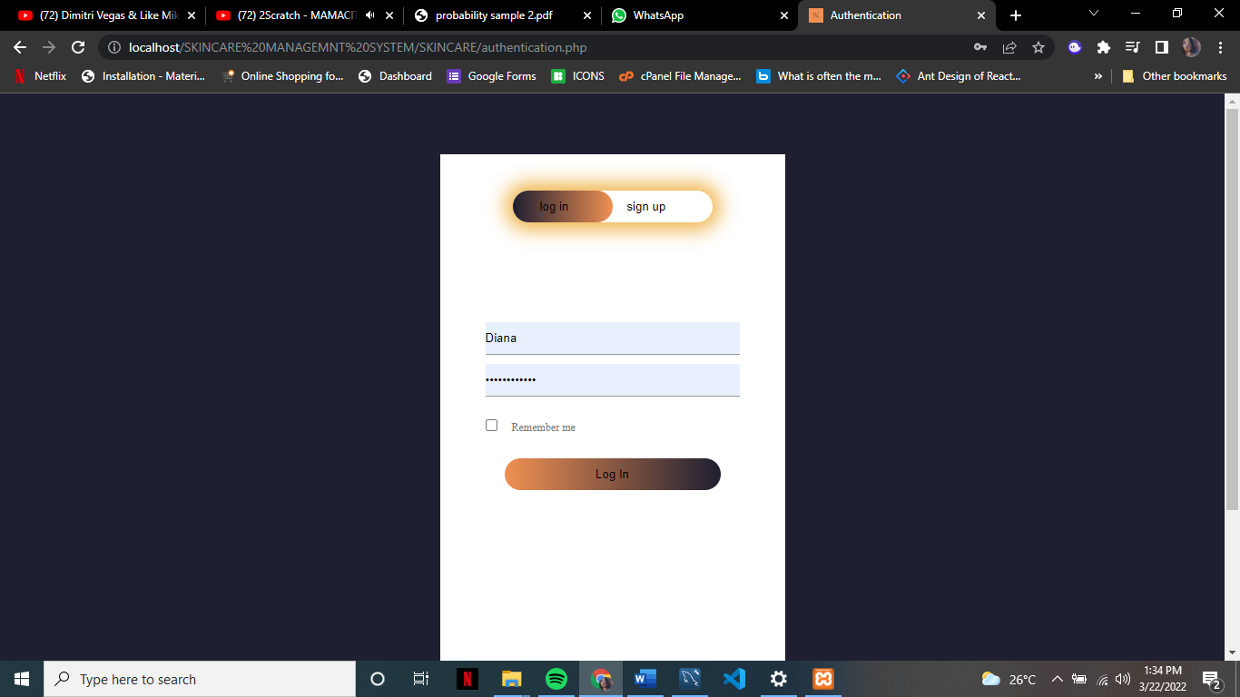

**Fig 1:** The login feature

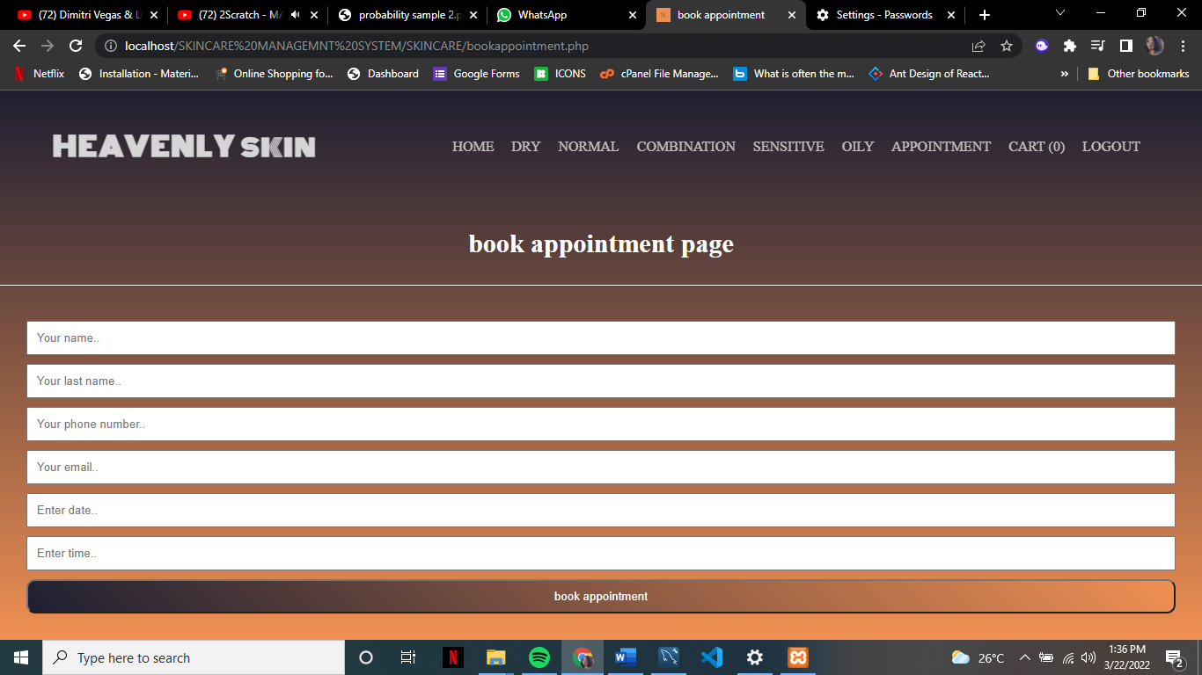

**Fig 2:** The book appointment feature

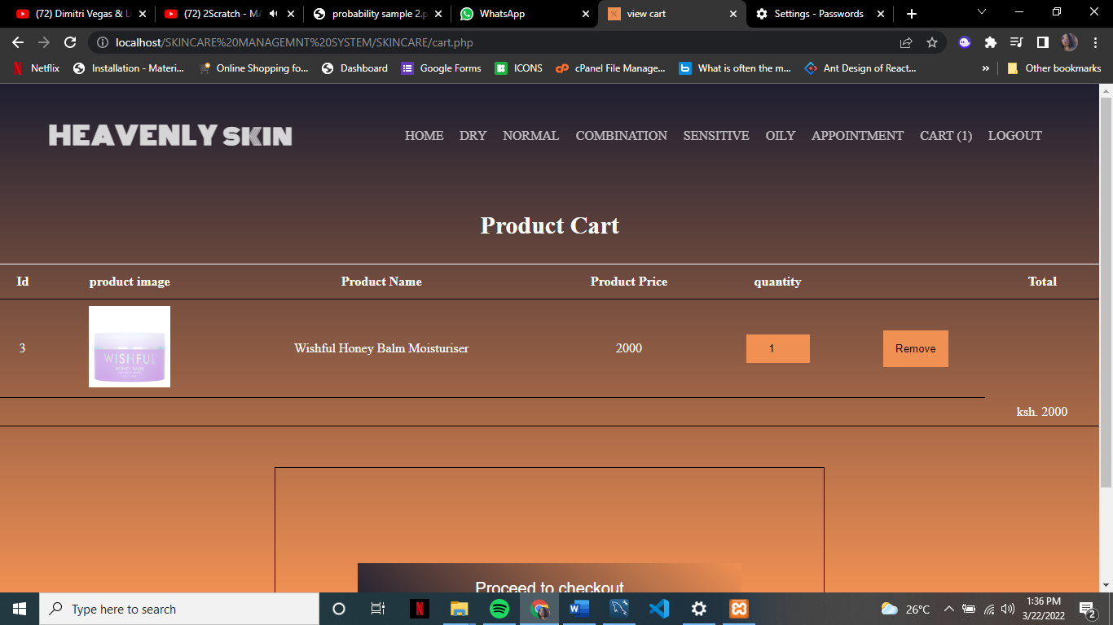

**Fig 3:** The add to cart feature

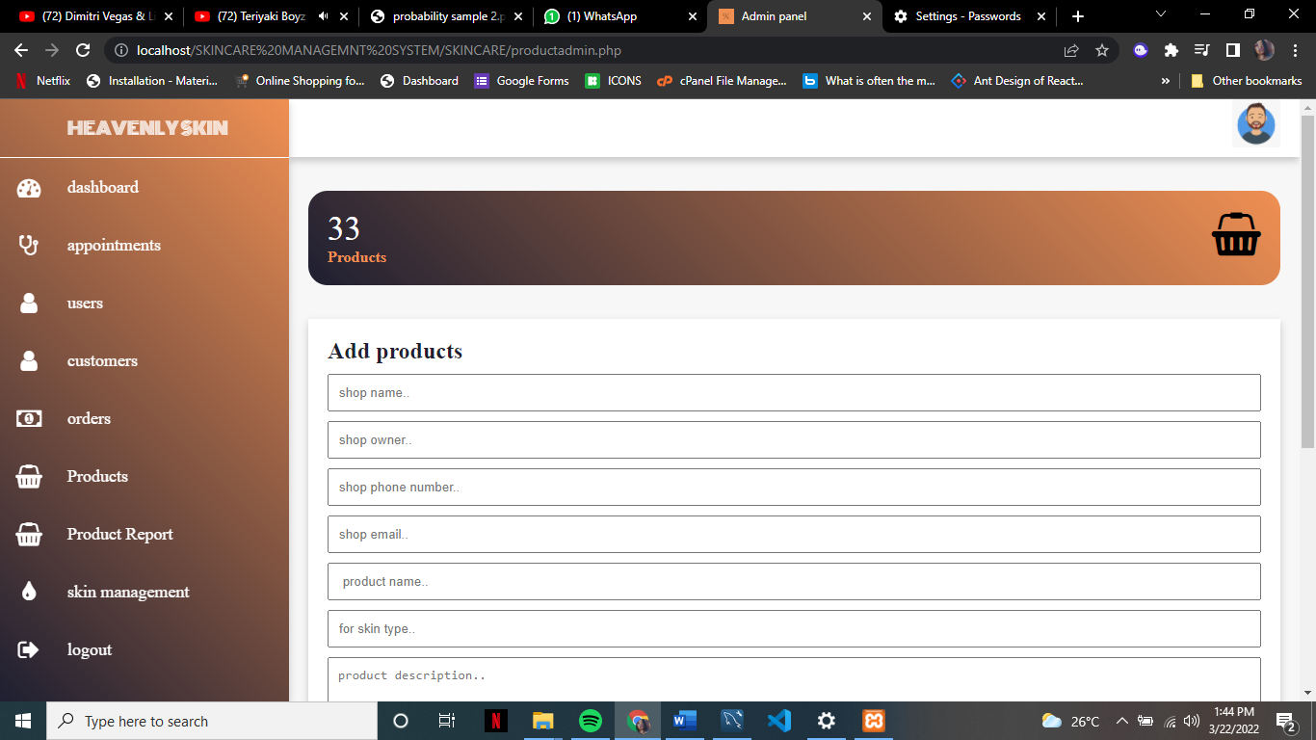

**Fig 4:** The add product feature

# CHAPTER 7: CONCLUSIONS, FINDINGS & RECOMMENDATIONS

## 7.1. Introduction

## 7.2. Conclusion

## 7.3. Challenges Encounter

## 7.4. Future recommendations

## 7.5. Conclusion

# REFERENCES/BIBLIOGRAPHY

# APPENDIX